Name: Pranali Sonawane
Subject: MCSA
Date: 4-12-2025
Lab : NTFS
- On Client1, create E and F drives of 2 GB each from the C drive.
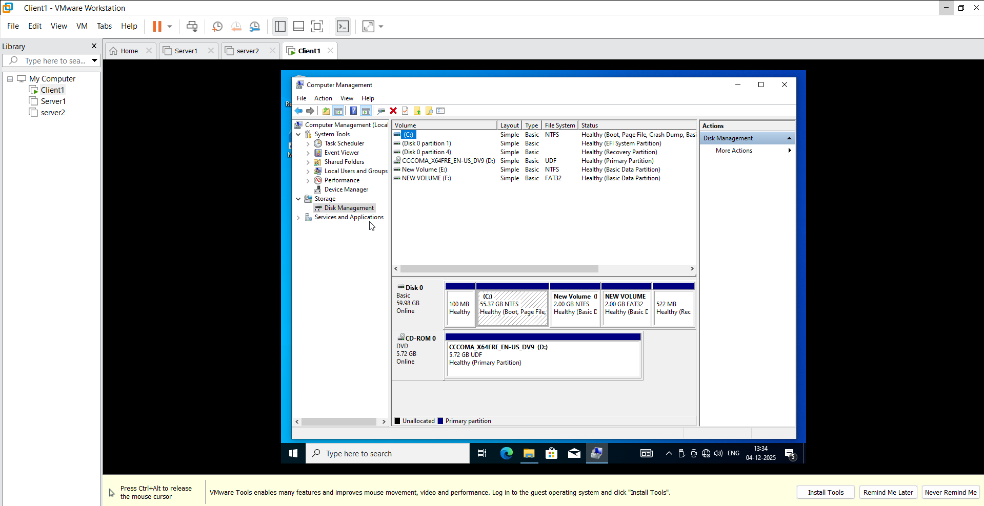
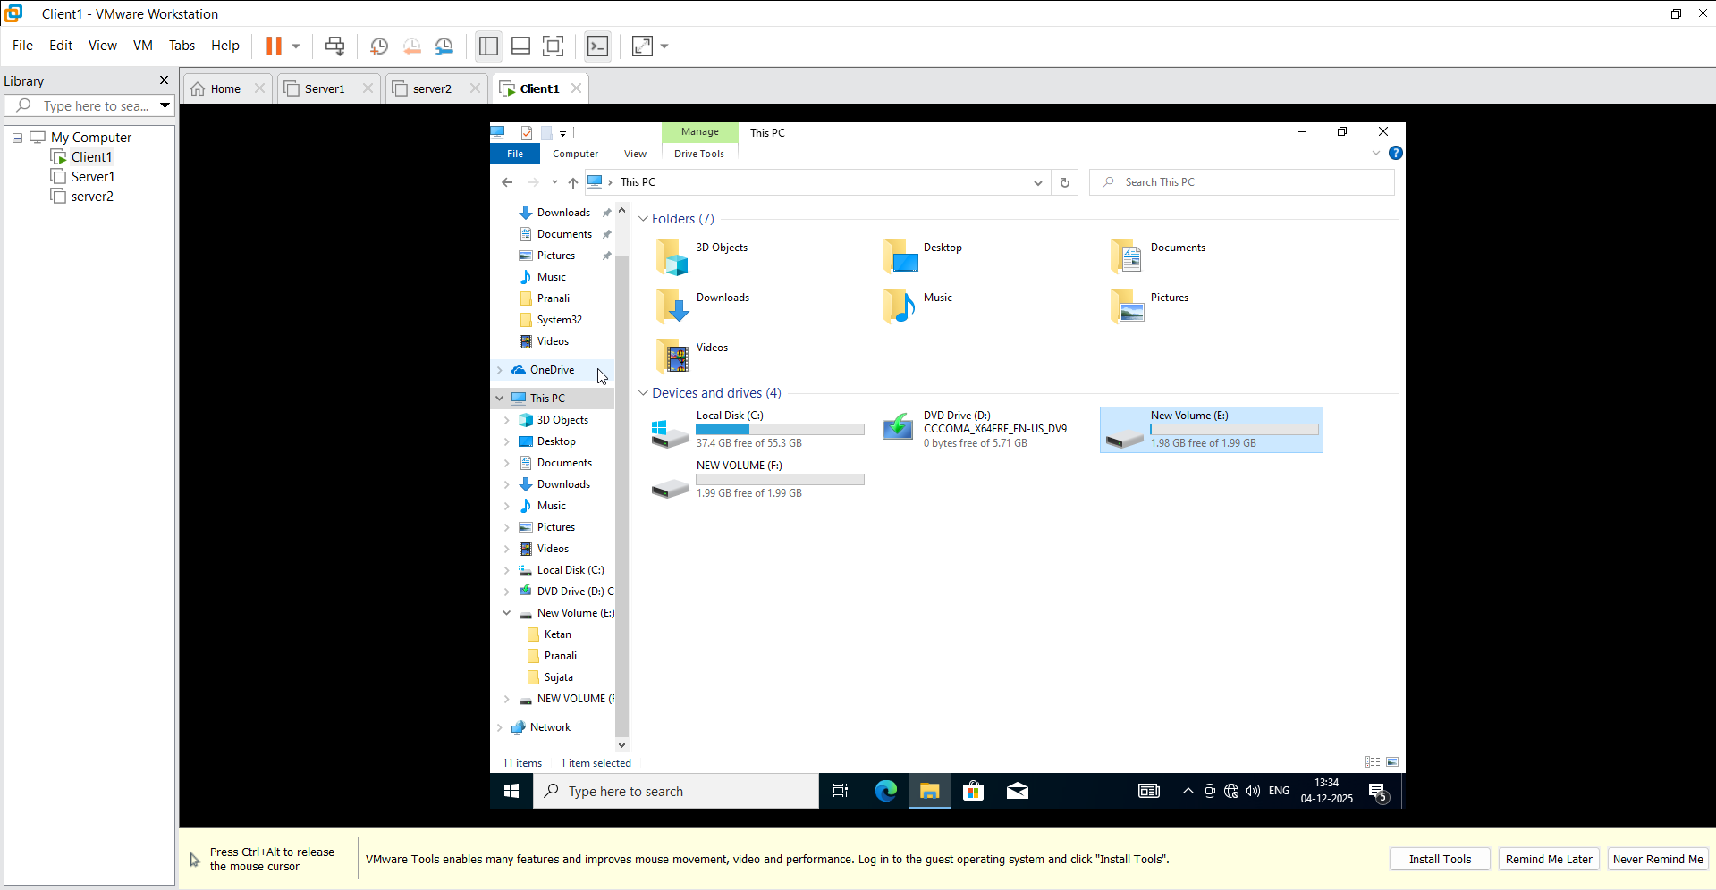
- E drive should be NTFS and F drive should be FAT32
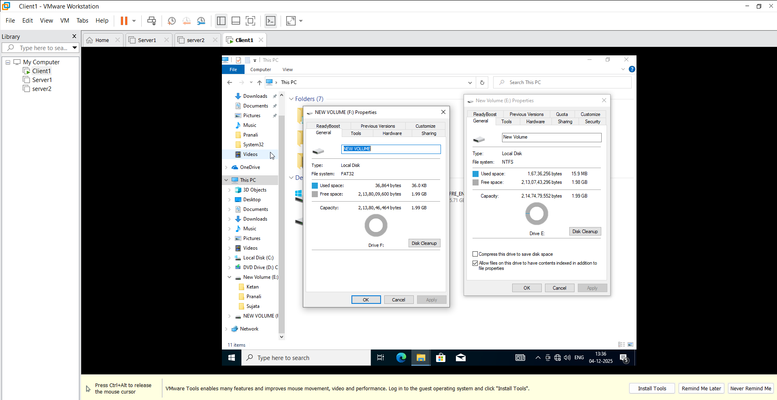
- E drive and F drive create 3 Folder suppose Name should be Ketan ,Pranali,Sujata
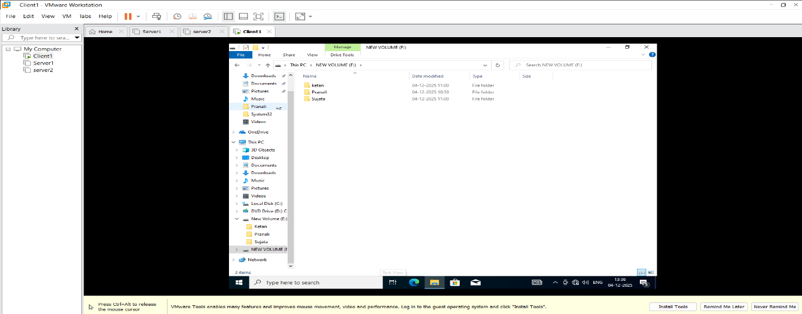
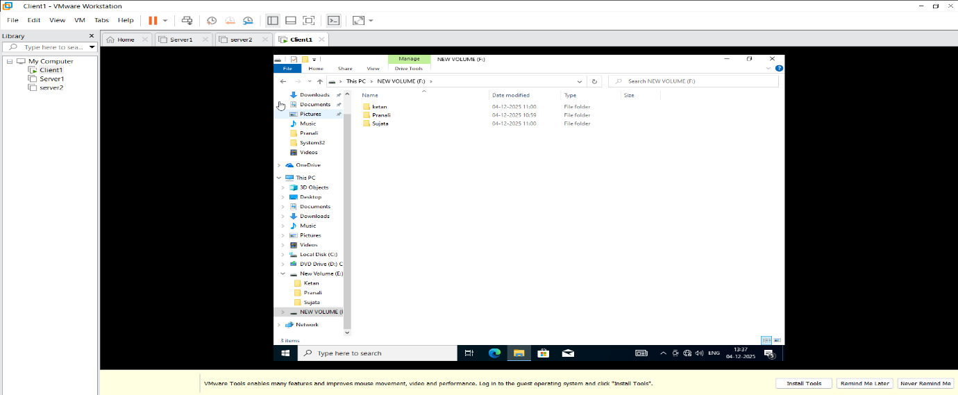
- E drive right click on that Properties
Authenticated Users (select on permission 1.Read and execute 2. List folder Contents 3. Read)
System (select on permission 1.Read and execute 2. List folder Contents 3. Read)
Administrators (select on Permission full control)
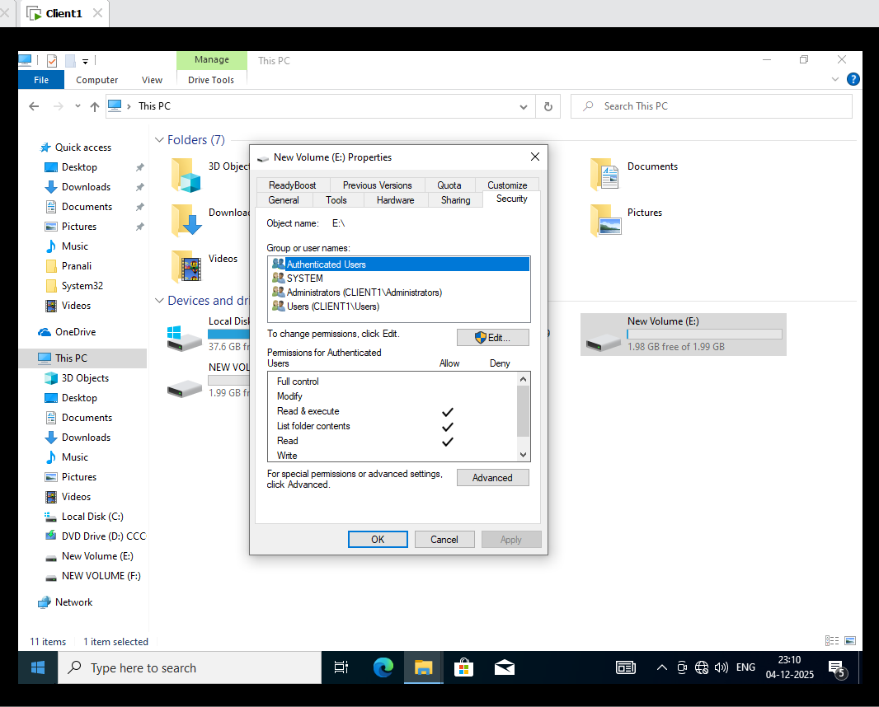
- E drive in that create folders in that first Ketan folder right click on Properties go to Security :

Authenticated Users (select on permission 1.Read and execute 2. List folder Contents 3. Read)
System (select on permission 1.Read and execute 2. List folder Contents 3. Read)
Administrators (select on Permission full control)
Crete a ketan user give me Permission full control
In that create a Pranali and Sujata users
Pranali (select on permission 1.Read and execute 2. List folder Contents 3. Read)
Sujata (select on permission 1.Read and execute 2. List folder Contents 3. Read)

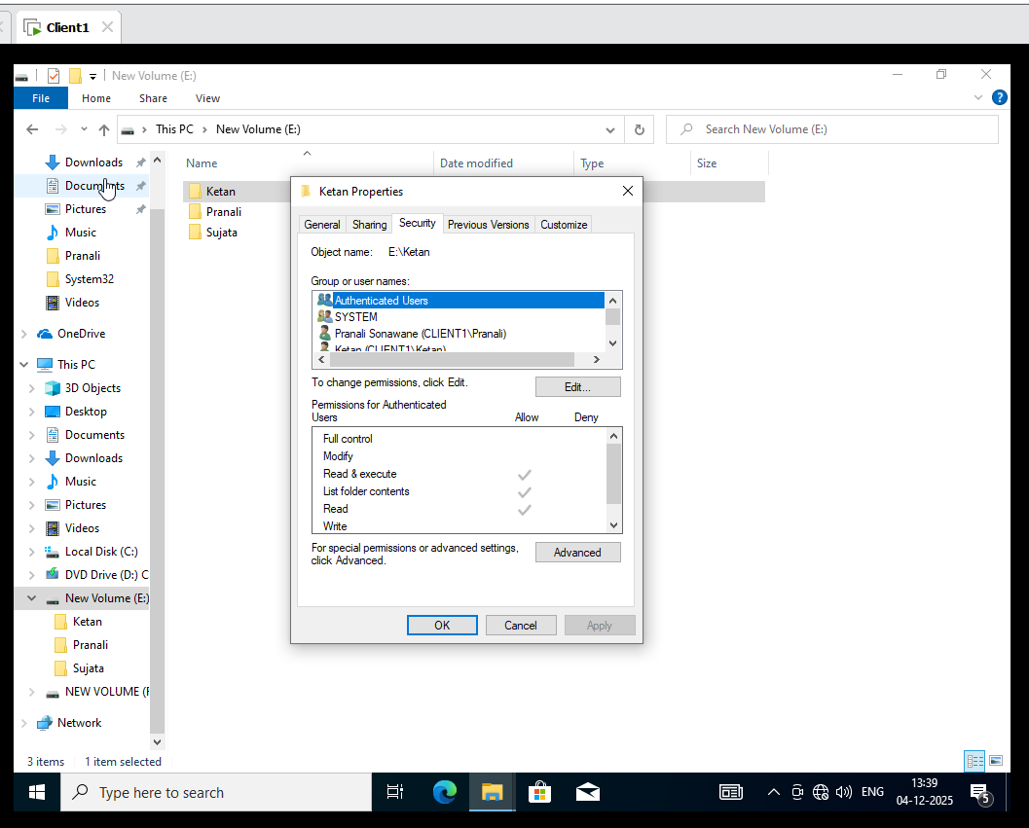
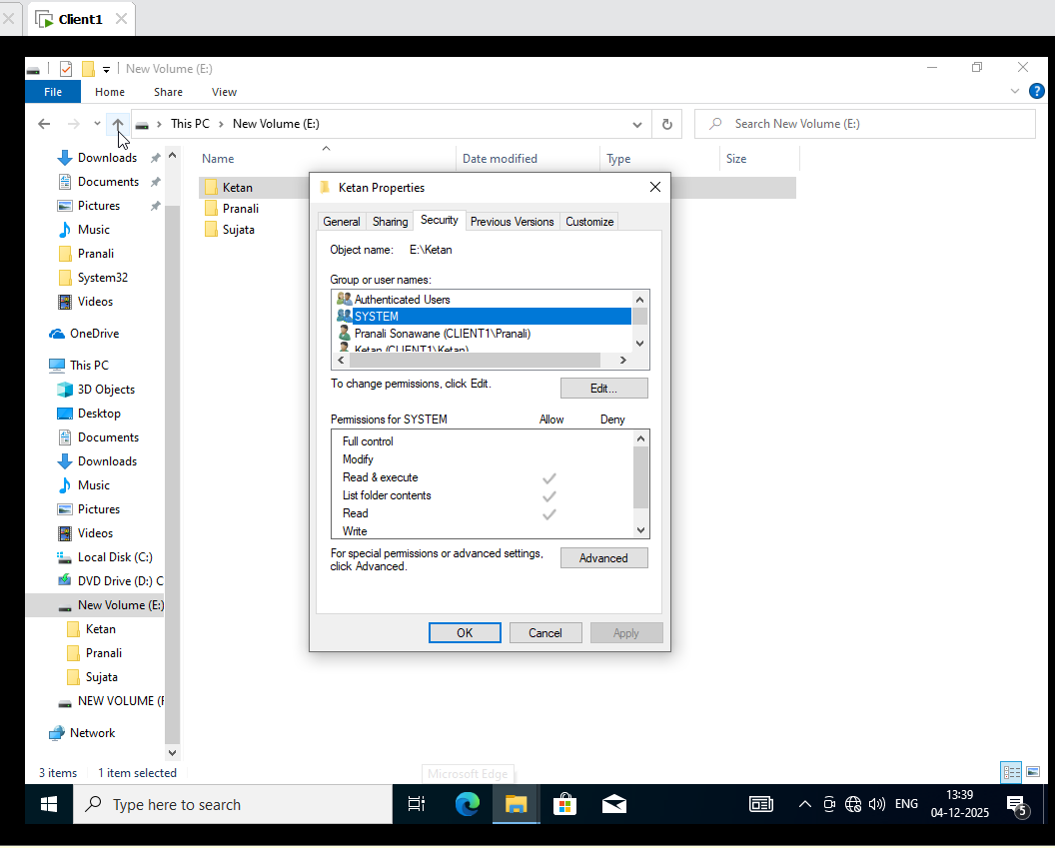
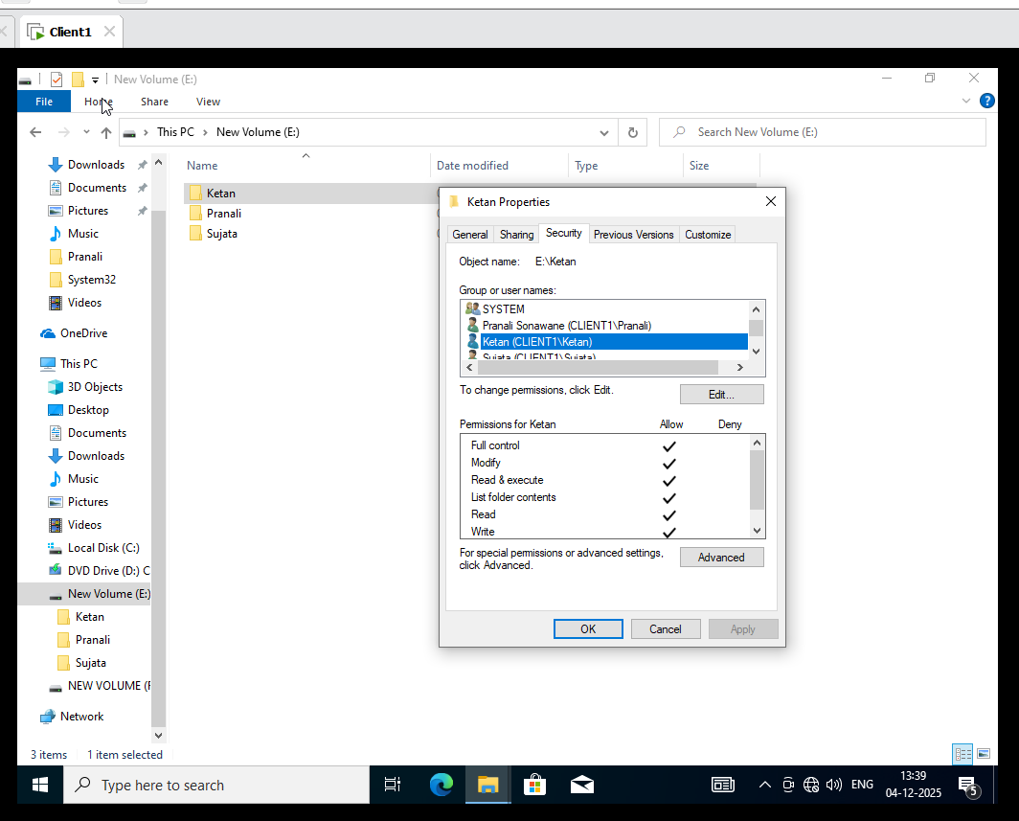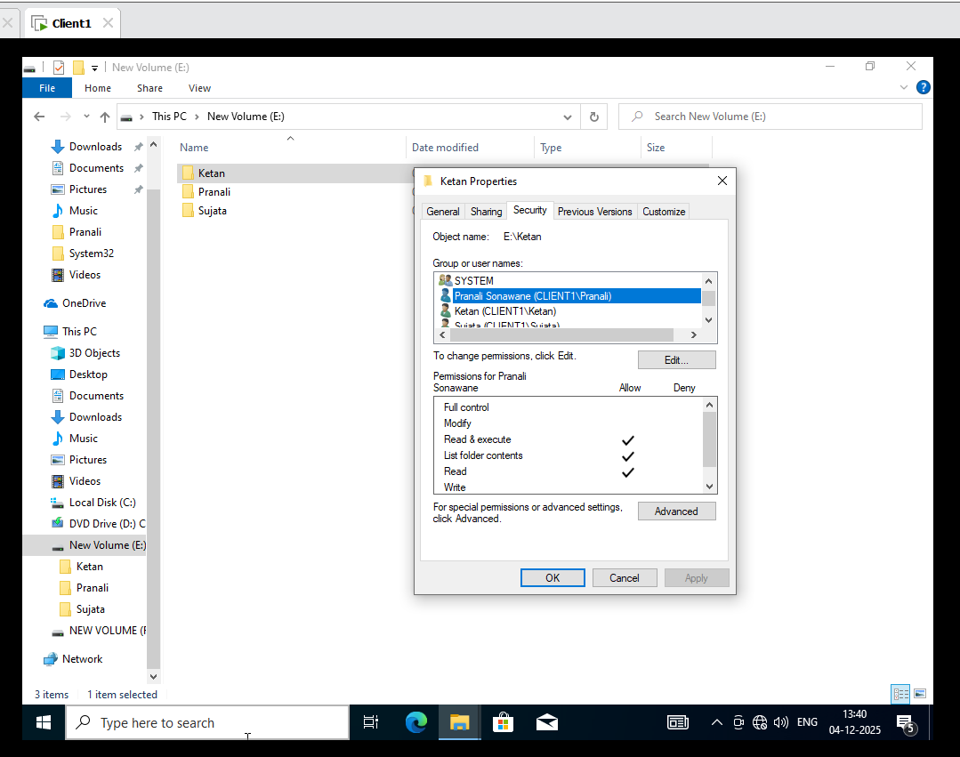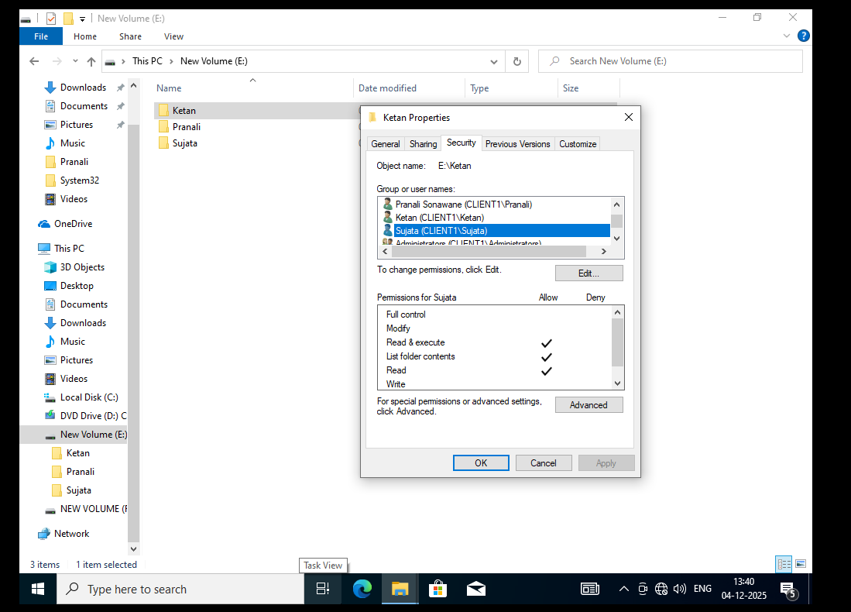
6. Go the Pranali Folder give Permission in that security :
Authenticated Users (select on permission 1.Read and execute 2. List folder Contents 3. Read)
System (select on permission 1.Read and execute 2. List folder Contents 3. Read)
Administrators (select on Permission full control)
Pranali (select on permission 1.Read and execute 2. List folder Contents 3. Read 4. write)
Ketan (select on permission 1.Read and execute 2. List folder Contents 3. Read)
Sujata (select on permission 1.Read and execute 2. List folder Contents 3. Read)

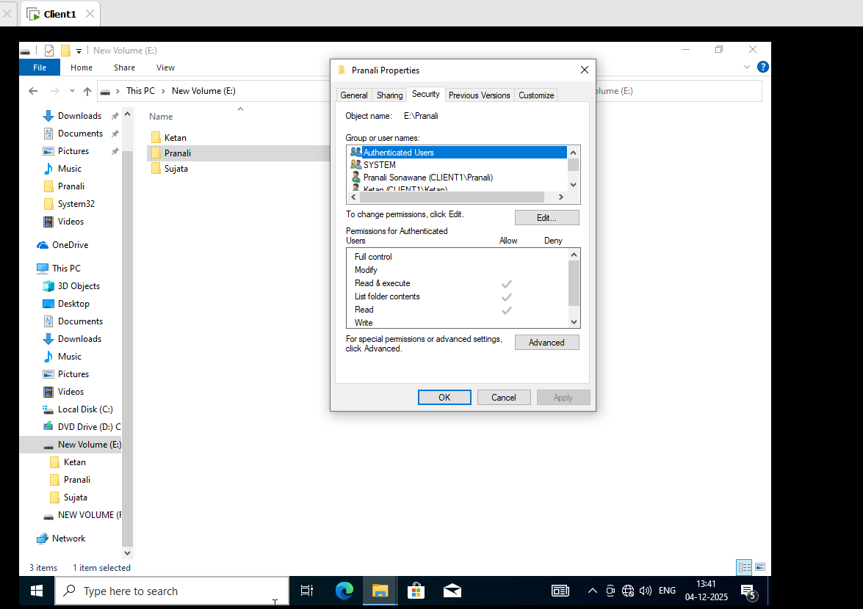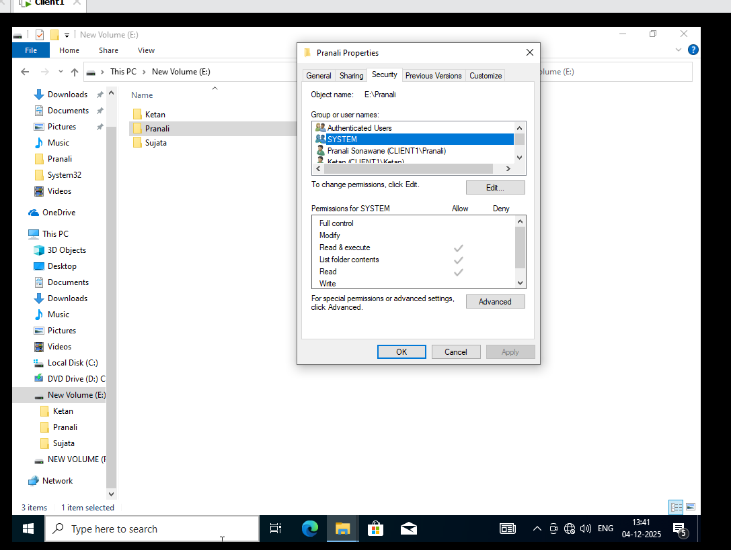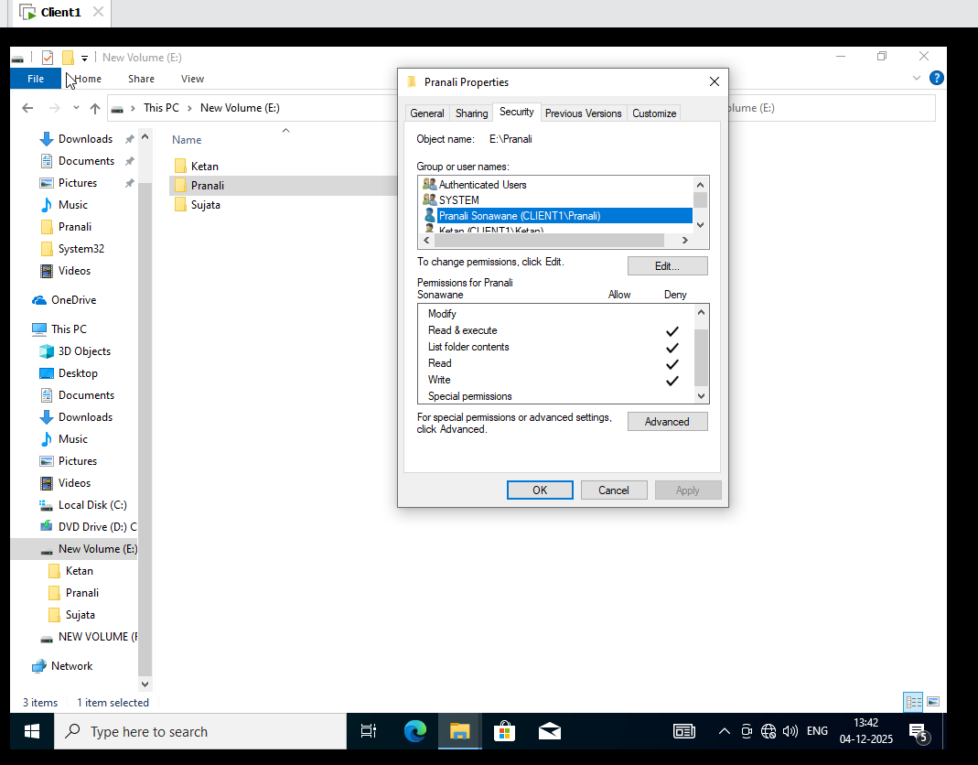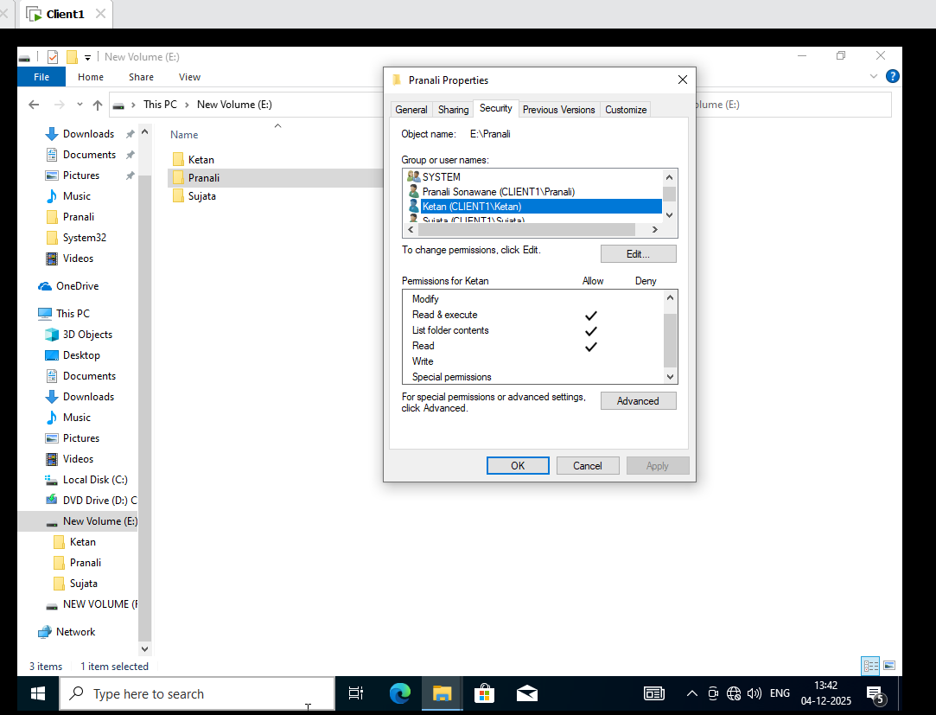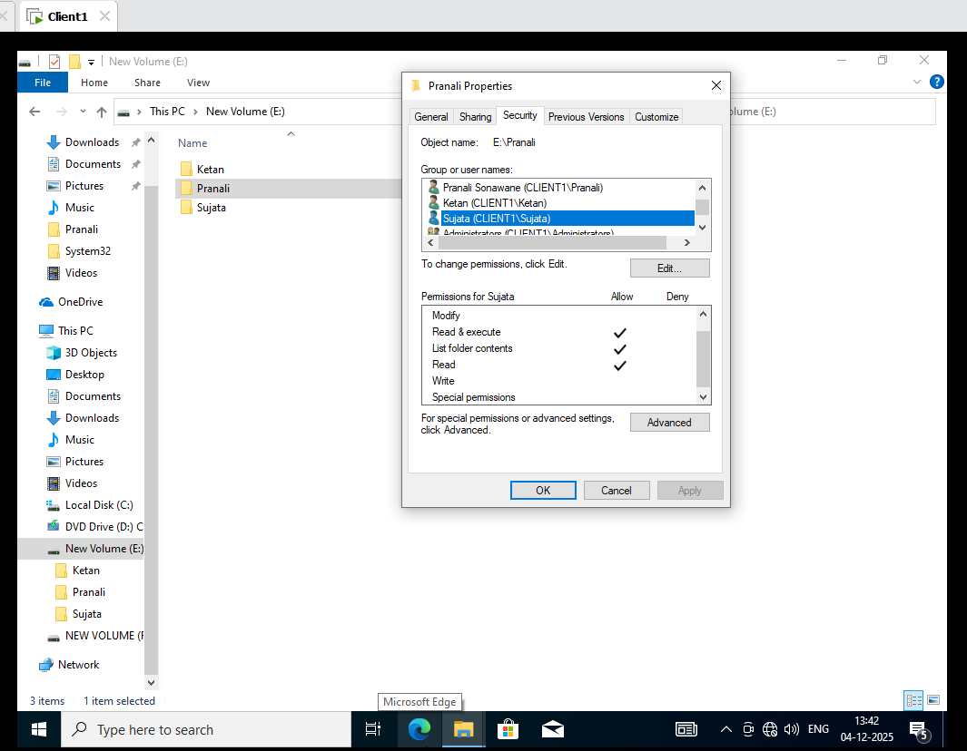
7. Go the Sujata Folder give Permission in that security :
Authenticated Users (select on permission 1.Read and execute 2. List folder Contents 3. Read)
System (select on permission 1.Read and execute 2. List folder Contents 3. Read)
Administrators (select on Permission full control)
Sujata (select on permission 1. Read )
Ketan (select on permission 1.Read and execute 2. List folder Contents 3. Read)
Pranali (select on permission 1.Read and execute 2. List folder Contents 3. Read)

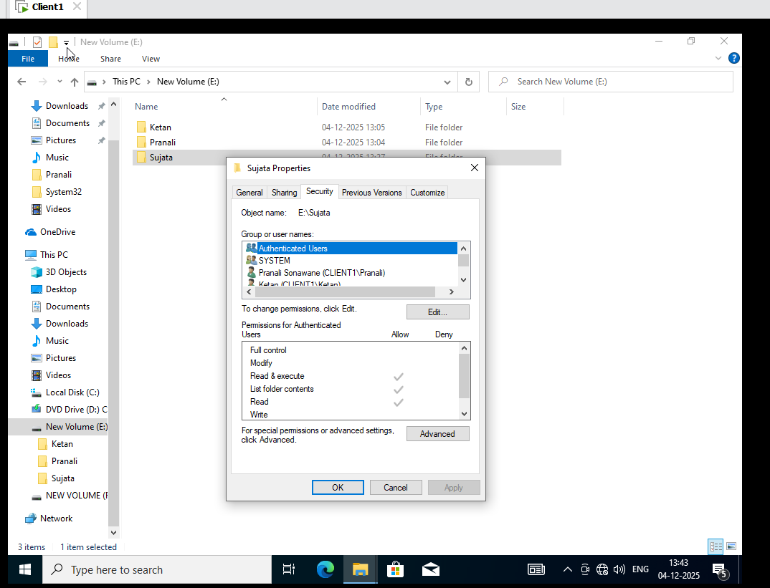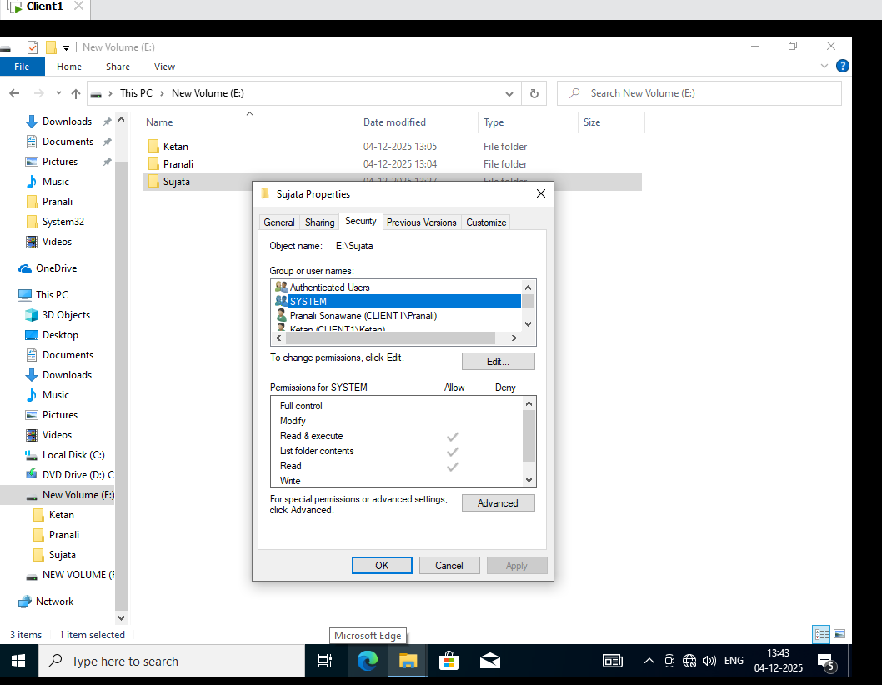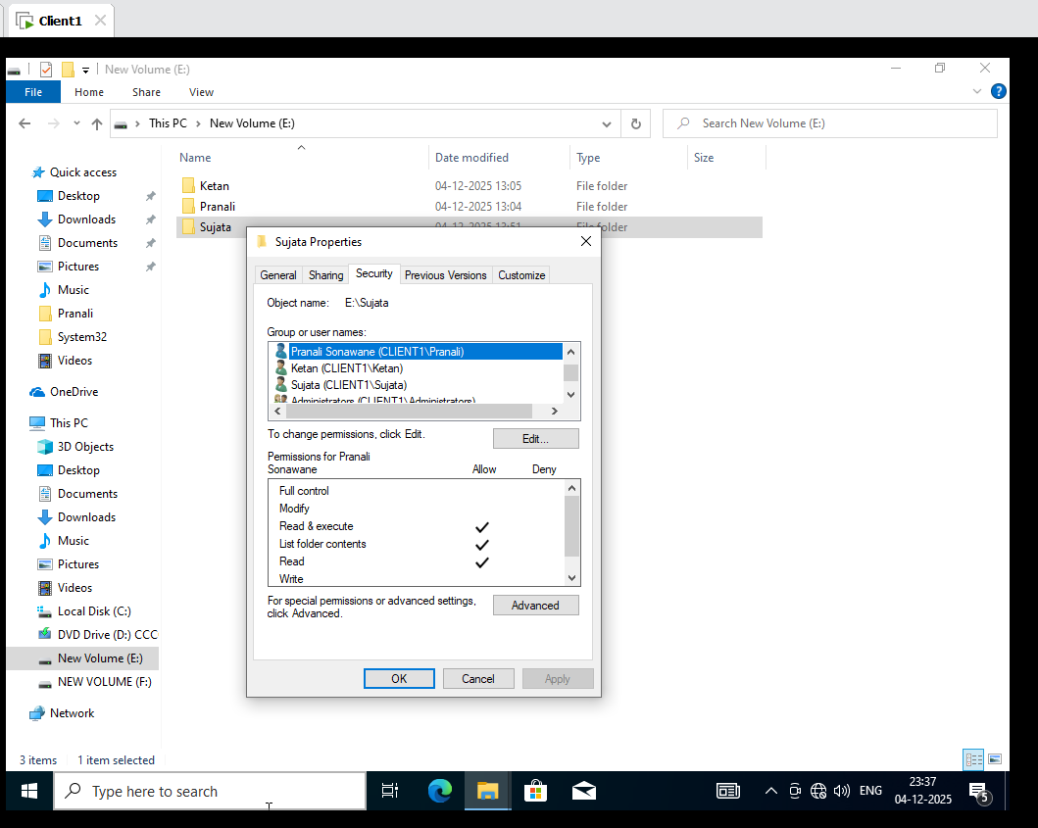
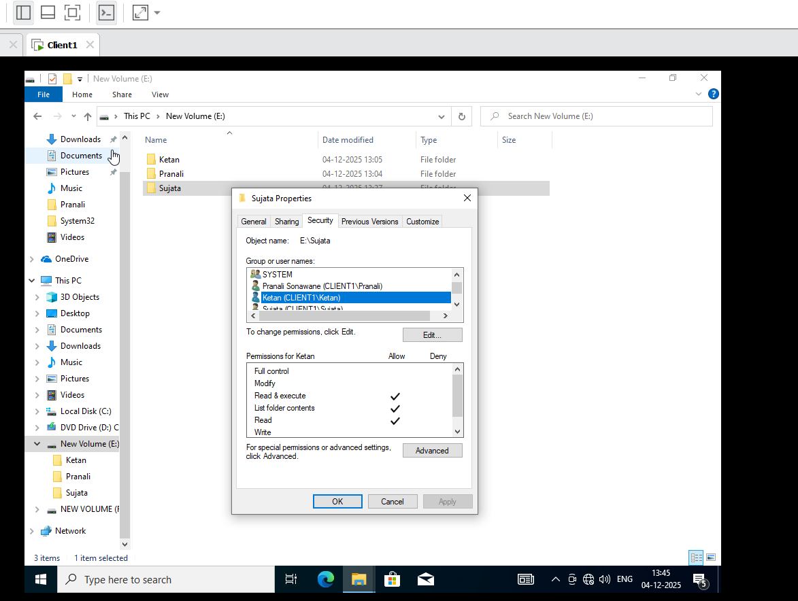
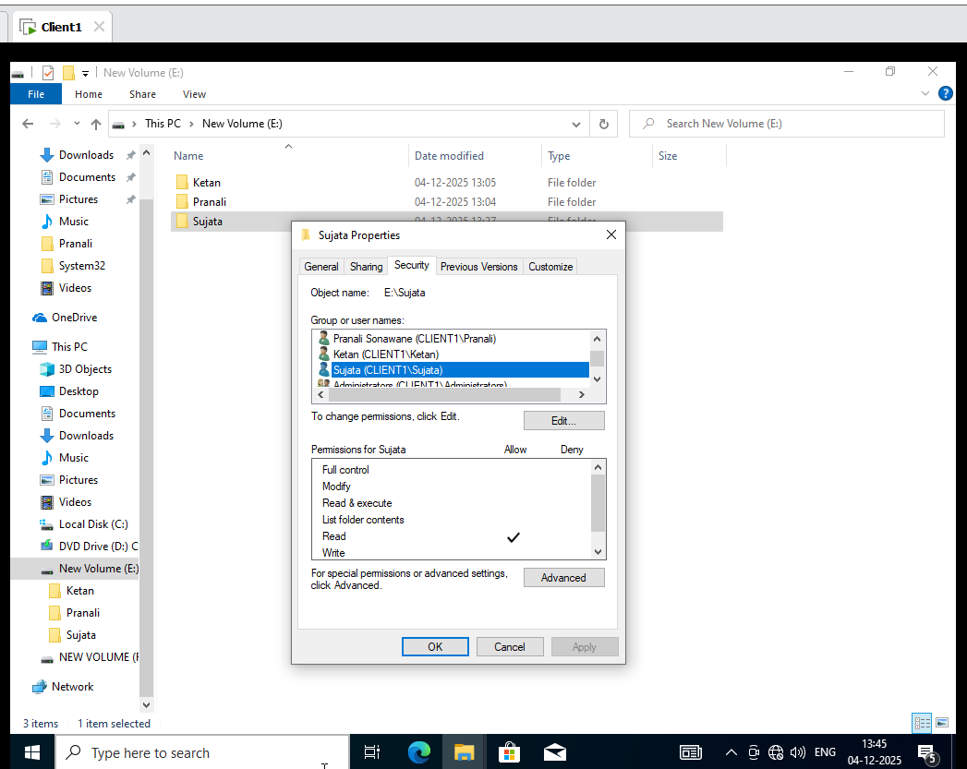
8. Sign in Pranali Profile:one text document on each folder
E drive in that Pranali Folder add text Document not create because Admin Pranali Folder give only Read Permission.
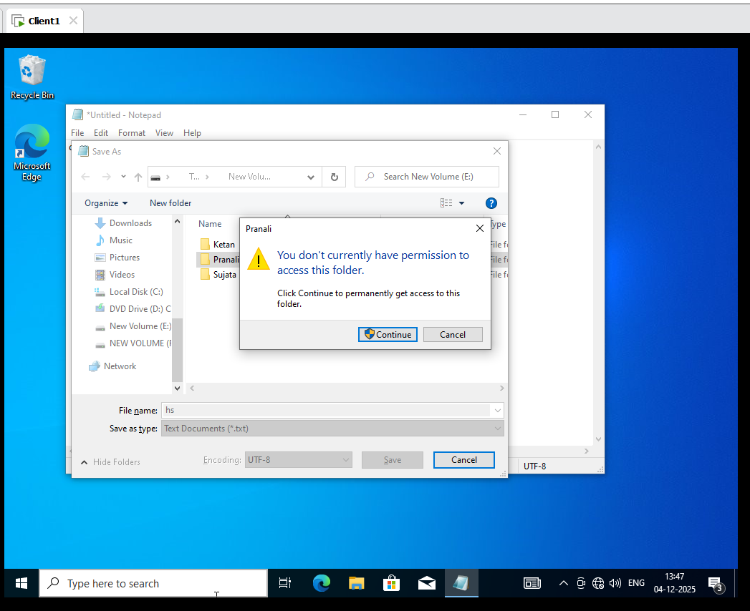
8. Sign in Sujata Profile:one text document on each folder
E drive in that Sujata Folder add text Document not create because Admin Sujata Folder give only Read Permission.

